Toyota Used Cars Track Insights

Easy Questions (SQL - Basic Aggregation & Filtering)
- What is the average price (price) of all cars in the entire dataset?
- Count the number of cars for each type of transmission (transmission).
- Identify the top 3 most common fuel types (fuelType) and the total count of cars for each.
- Find the maximum and minimum price (price) recorded in the dataset.
- How many cars were manufactured in each year (year)? Display the results sorted by year.
- What is the average mileage (mileage) for cars with the model 'Fiesta'?
- List all unique engine sizes (engineSize) present in the data.
- Count the number of cars that have an annual tax (tax) greater than 150.
- What is the average mpg (miles per gallon) for cars manufactured in 2017 (year)?
- Find the price and model of the car with the largest engine size (engineSize).

Îmi cer scuze pentru inconvenient! Folosesc formatarea LaTeX ($\text{nume\_coloană}$) pentru a sublinia că este vorba de o coloană din baza de date, dar înțeleg că acest lucru face copierea dificilă.
Iată lista completă de 30 de întrebări, reformulată fără nicio formatare specială (fără LaTeX, fără bold, doar text simplu), gata de a fi copiată.

Easy Questions (SQL - Basic Aggregation & Filtering)
- What is the average price (price) of all cars in the entire dataset?
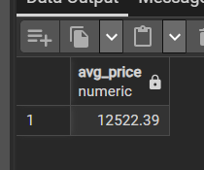
- Count the number of cars for each type of transmission (transmission).
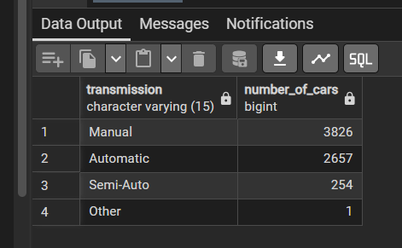
- Identify the top 3 most common fuel types (fuelType) and the total count of cars for each.
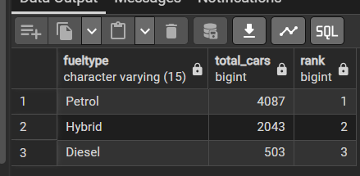
- Find the maximum and minimum price (price) recorded in the dataset.
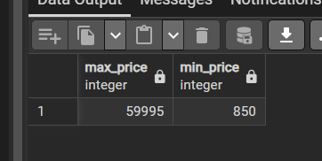
- How many cars were manufactured in each year (year)? Display the results sorted by year.
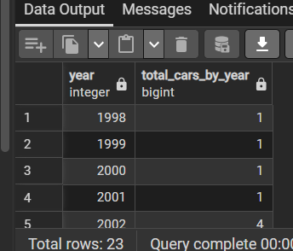
- What is the average mileage (mileage) for cars with the model 'Fiesta'?
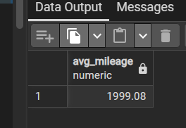
- List all unique engine sizes (engineSize) present in the data.
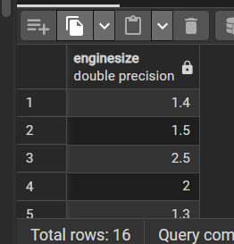
- Count the number of cars that have an annual tax (tax) greater than 150.
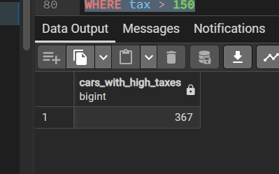
- What is the average mpg (miles per gallon) for cars manufactured in 2017 (year)?
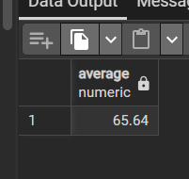
- Find the price and model of the car with the largest engine size (engineSize).
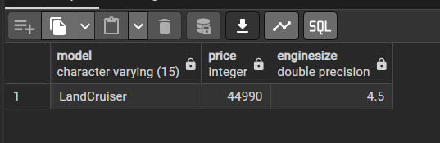

Medium Questions (SQL - Subqueries, CTEs, and Conditional Logic)
- Calculate the average price (price) for cars grouped by fuelType and transmission.
- Determine the percentage of the total car count that each fuelType represents.
- Find the models (model) whose average mpg is higher than the overall average mpg of all cars.
- Identify the models (model) that have both Automatic and Manual transmission options present in the dataset.
- Assign a 'Tax Bracket' (Low, Medium, High) based on the tax column (Low $\le$ 100, Medium > 100 and $\le$ 300, High > 300). Count how many cars fall into each bracket.
- Calculate the median mileage (mileage) for cars manufactured in the last 5 years available in the dataset.
- Find all cars where the price is below the average price for its specific model.
- What is the difference between the average mpg of the most expensive model and the average mpg of the cheapest model (based on average price)?
- List the model and year combinations that have a combined total mileage exceeding 500,000 miles.
- Calculate the average engineSize for cars that cost more than the 75th percentile of the price distribution.

Îmi cer scuze pentru inconvenient! Folosesc formatarea LaTeX ($\text{nume\_coloană}$) pentru a sublinia că este vorba de o coloană din baza de date, dar înțeleg că acest lucru face copierea dificilă.
Iată lista completă de 30 de întrebări, reformulată fără nicio formatare specială (fără LaTeX, fără bold, doar text simplu), gata de a fi copiată.

Easy Questions (SQL - Basic Aggregation & Filtering)
- What is the average price (price) of all cars in the entire dataset?
- Count the number of cars for each type of transmission (transmission).
- Identify the top 3 most common fuel types (fuelType) and the total count of cars for each.
- Find the maximum and minimum price (price) recorded in the dataset.
- How many cars were manufactured in each year (year)? Display the results sorted by year.
- What is the average mileage (mileage) for cars with the model 'Fiesta'?
- List all unique engine sizes (engineSize) present in the data.
- Count the number of cars that have an annual tax (tax) greater than 150.
- What is the average mpg (miles per gallon) for cars manufactured in 2017 (year)?
- Find the price and model of the car with the largest engine size (engineSize).

Medium Questions (SQL - Subqueries, CTEs, and Conditional Logic)
- Calculate the average price (price) for cars grouped by fuelType and transmission.
- Determine the percentage of the total car count that each fuelType represents.
- Find the models (model) whose average mpg is higher than the overall average mpg of all cars.
- Identify the models (model) that have both Automatic and Manual transmission options present in the dataset.
- Assign a 'Tax Bracket' (Low, Medium, High) based on the tax column (Low $\le$ 100, Medium > 100 and $\le$ 300, High > 300). Count how many cars fall into each bracket.
- Calculate the median mileage (mileage) for cars manufactured in the last 5 years available in the dataset.
- Find all cars where the price is below the average price for its specific model.
- What is the difference between the average mpg of the most expensive model and the average mpg of the cheapest model (based on average price)?
- List the model and year combinations that have a combined total mileage exceeding 500,000 miles.
- Calculate the average engineSize for cars that cost more than the 75th percentile of the price distribution.

Hard Questions (SQL - Window Functions, Complex Ranking, and Modeling)
- For each model, calculate the Z-score for the price of every car. (Z-score = (price - AVG(price)) / STDDEV(price) within the model group).
- Rank all cars based on their 'Value Index', defined as the ratio of (price / (mileage + 1)) within each model group.
- Identify the top 10% of cars that offer the highest mpg relative to their engineSize. (maximize mpg / engineSize)
- Calculate the cumulative sum of price over year for each transmission type.
- Calculate the average annual depreciation rate for each model in the dataset. (Assume the current year is 2025: Rate = price / (2025 - year)).
- Identify cars that are potentially "overpriced" by having a price that is 50% higher than the average price of cars with the same model and similar mileage (mileage binned into 5,000 intervals).
- Compare the average tax of cars in the current year (year) to the average tax of cars from the previous year (year - 1). List the percentage increase/decrease for each year.
- Find the models (model) that have the lowest tax rate (tax / price) compared to all other models with the same engineSize (within 0.1L tolerance).
- Determine the models (model) that saw an increase in price and a simultaneous decrease in mileage between two consecutive manufacturing years (year and year + 1).
- For the top 5 most common models, calculate the correlation coefficient between price and mileage.

